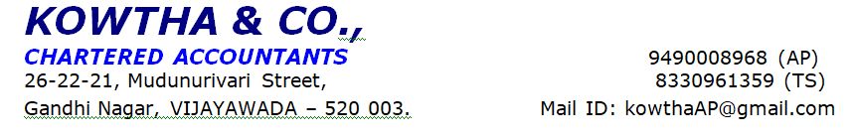

PERSONAL DISCUSSION REPORT

Name of the Applicant | XXX
SDFC ID | 400437078863
Person Contacted | XXXX
Visited Address | XXXX
Date of Visit/ Time of visit | 29-5-2025 ; 04.20 pm
Alternate contact number of the customer (Mobile/Landline) | XXX
Marital Status (Married/Divorced/Bachelor) | Mrried
Name Of The Employer | M/S. XXXX
Type Of Firm (Proprietor / Partnership / Pvt. Ltd. / Govt. /PSU / MNC) | Private limited
Number Of Employees | -
Department And Designation | Department: Engineering  Designation: Associate Consultant
Years In Current Company | As Informed, Applicant Is Working In This Company from 03 years
Previous Job Details / Work Experience / Total Years Of Experience | Total Work Experience: 5 yrs.
Level of activity & stocks along with observations | NA
Company Profile ( Service / Manufacturing / Small Scale / Finance / Other [Please Specify]) | Software
Third Party Check | Positive
INCOME DETAILS:-
Gross Salary | Rs. 2,08,200/- per month
Net Salary | Rs. 1,69,292/- per month
Overtime Details, If Any | NA
Monthly Expenses | -
Monthly Net Income | -
Total no of family members | - Wife:XX -33 years -jr proffecer-salary-Rs.48,000/-  - Son:XXX-4 years  - Father:XXX  - Mother:XXX -50 years
Earning Family Members income details | NA
No. Of Dependents | 04
Any other source of income Monthly/ Annual | NA
BANKING DETAILS: -

Banking Relationship with | Standard chartered- Salary -10 years
Cash Credit Limit | -
Overdraft limit | -
OBLIGATIONS/LOANS:-

Institution / Bank / NBFC Name | Type of Loan (LAP / HL / CD / CV / AL etc.) | Monthly Principal / EMI | Loan amount  Rs. Lacs
Lic |  | Rs.42,000/- | Rs. 48,00,000/-
ICICI | Pl | Rs. 65,000/- | Rs. 35,00,000/-

Current Residence (Owned/ Rented/ Parents House/ Relatives House/ Relatives House/ Company Provided) | Owned
Years At Current Residence | X
Assets owned:-
Four Wheeler : _____(Make/Model)  Two Wheeler : ____(Make/Model) | Not provided
BIL LOAN DETAILS:
Loan amount applied | Rs. 22 lakhs
End Use | persanal loan-home renovation
Name of Interviewer | XXX
Designation and signature | XXX
PD Status | Positive.
Interviewers remarks | - The applicant is Mr. XXX is age 34 yrs and native of rly koduru  - He is working as Associate Consultant in M/S. XXXX  - He has 03 years working experience in this company.  - His designation is Associate Consultant  - Date of joining in this company since 04-11-2022  - Employee number XXXX  - He receives Gross Salary of Rs. 2,08,200/- per month. and Net Salary Rs. 1,69,292/- per month (As per April month Pay Slip)  - He provided employee ID card.  - He provided Last 6 Months Pay-slips.  - He provided bank statement at the time of visit.  - He receives salary through bank.  - Actually, he is getting incentives along with his salary and total amount will be reflected as his salary at his bank statement  - At present applicant is doing work from home

Disclaimer Clause:
This report (including any attachments) has been prepared based on verbal information provided by the person contacted. IDFC FIRST BANK will be solely responsible for any actions taken on this report and any liabilities directly or indirectly accruing from such actions. M/s. KOWTHA & CO will not be held liable in any case
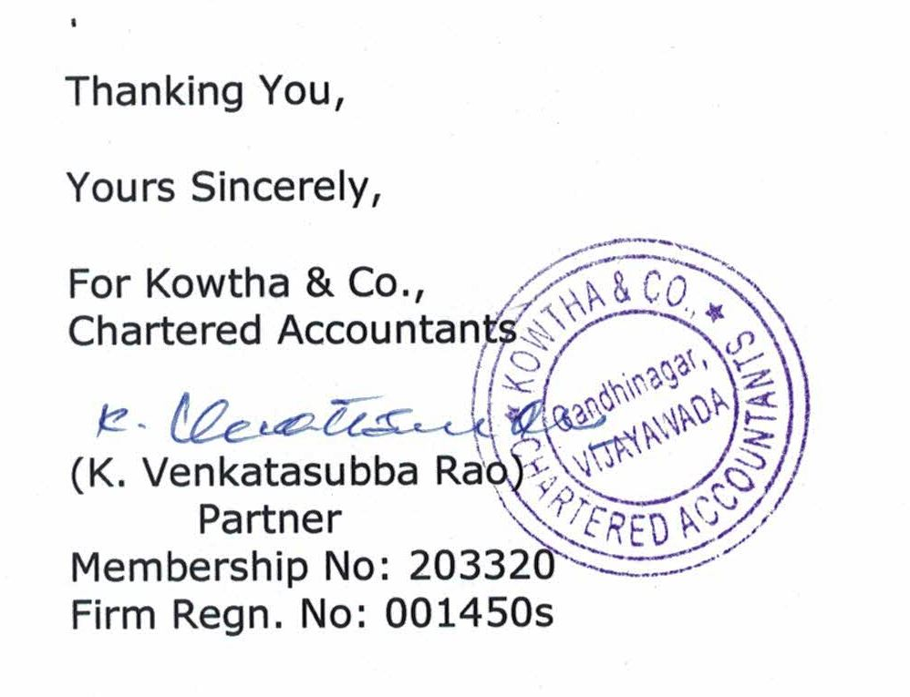

Photos :

